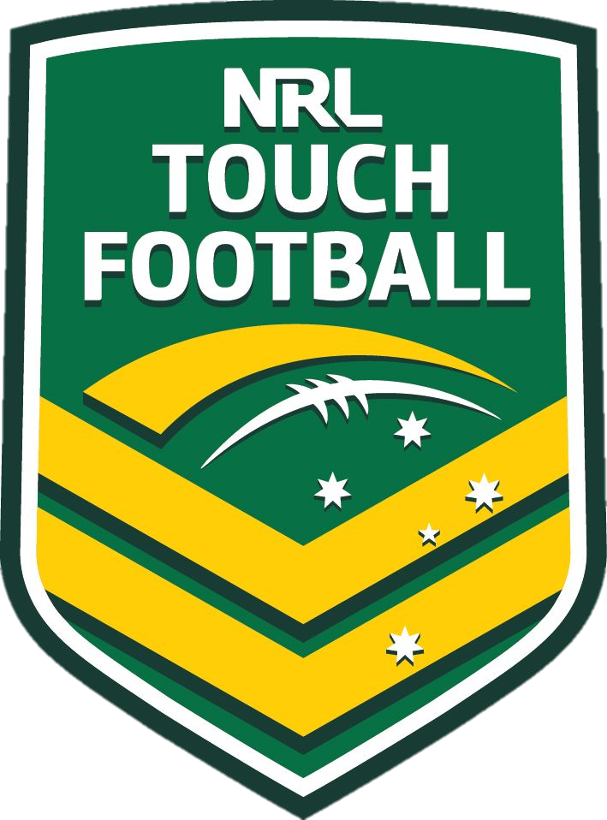
2020

Referee Information Package
MEMORIAL CHAMPIONSHIPS
PETER WILSON
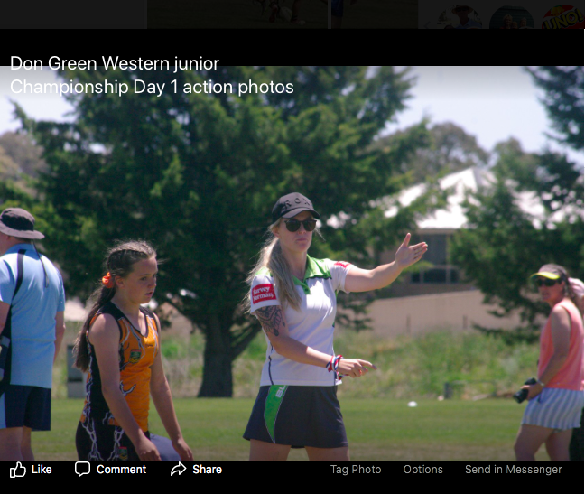
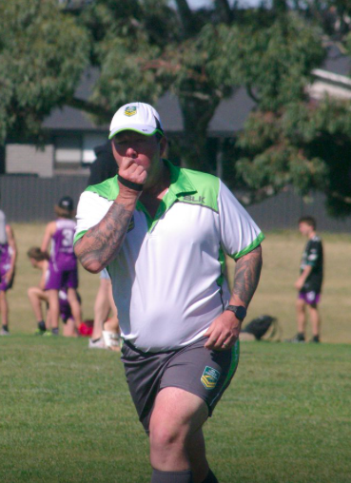
NSW: HORNETS REGIONAL TOUCH

Covering Hunter & Western New South Wales
To: Attending Affiliates and Attending Referees
From: Amanda Draper – Regional Director of Referees
Subject: Peter Wilson Memorial Championships - Referees Information

I’m pleased to confirm that this years PWMC is the BIGGEST YET! With over 180 teams, in excess of 210 referees and additional playing fields, we’re ready for a mamoth tournament.
THIS BOOK: Please take the time to read through this thoroughly. You will need to retain this package for use as reference material. Please be aware that there is important new information in this booklet, in particular the brand-new scorecard procedure which you must be familiar with.
GAME TRENDS: With game trends changing so often it’s important we, as referees, keep on top of what our requirements are on and off the park. Which is why it is always important to keep on top of the basics. Therefore this year’s PWMC will involve progression and development, but also mastering the basics as a referee. I will explain these expectations further in this booklet.
REFEREE COMMUNITY: As Regional Director of Referees there’s one thing above all that I am proud of – the way we work together as one big referee contingent. No matter if you’re a new referee or a long serving member, we are all a part of the Hornets Regional Referee Family, and I encourage you to chat and make new friends at PWMC. The panel and I look forward to working and speaking with everyone at this jam packed and exciting event.
HELP? If there is anything you are unsure of, or if I can be of any further assistance, please don’t hesitate to contact me on 0427 482 706 or email referees@hornetstouch.com.au
Kind Regards
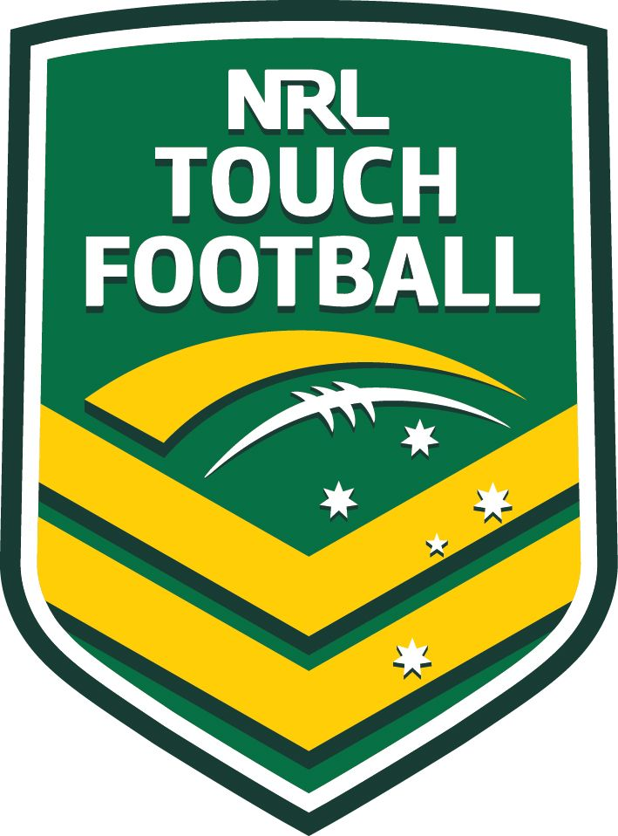
Amanda Draper
REGIONAL DIRECTOR OF REFEREES

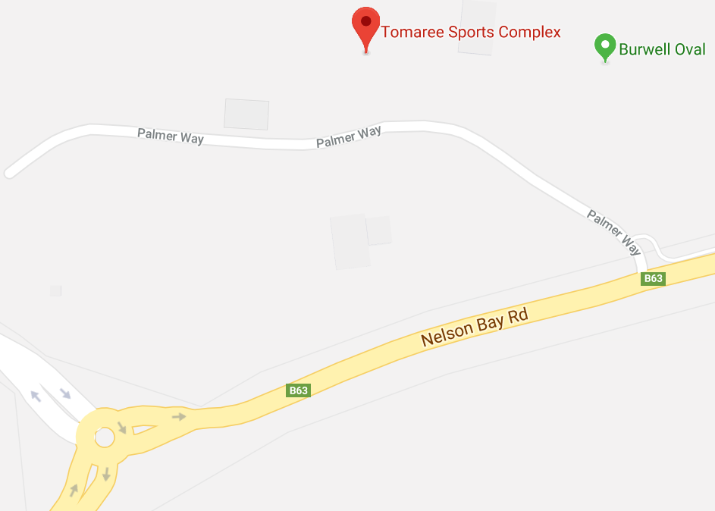
GENERAL INFORMATION
Date: Saturday, 1 and Sunday, 2 February 2020
This event is always in the first weekend in February, so mark it in every year!

Venue: Nelson Bay Touch Fields,
Tomaree Sports Complex – Nelson Bay Road, Salamander Bay, NSW

YOUR REGIONAL REFEREE COACHING PANEL

2019-2020 PANEL

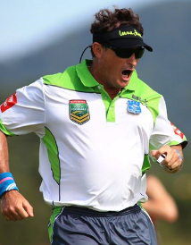
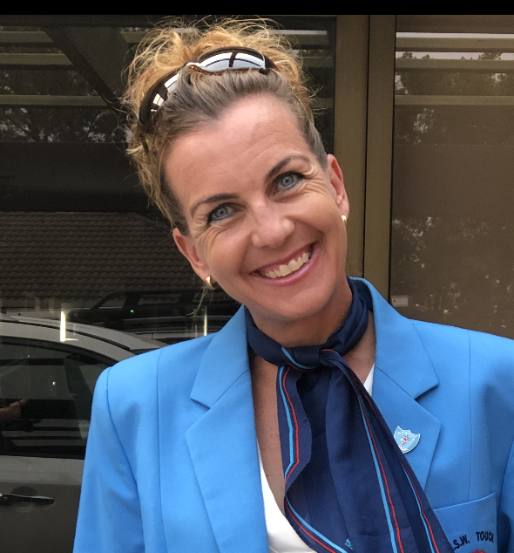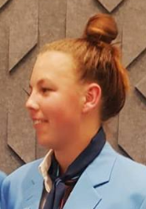
Sam Alec Amanda Amy Tess Paul
Clark Clark Draper Draper Leahy Keyte

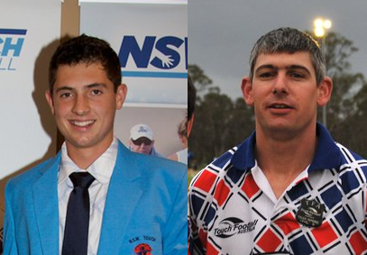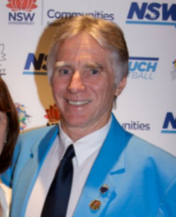
Josh Chris Kim Jordyn John
Little Reynolds Skelly Tomba Turnbull
Teams [this tournament] | Panel Members | Duties
Tournament Coordinators | Amanda Draper | The ‘Go-To Person’– The Tournament Coordinator is the spokesperson on behalf of the Regional Director of Referees and the Regional Referee Panel, coordinating the morning meetings and ensuring the smooth running of referee logistics.
Appointments Panel | Kim Skelly (lead), Sam Clark, Jordyn Tomba & Amanda Draper | Appoint referees to finals matches and provide development support and opportunities to emerging elite referees from within the Hornets region.
L1>L2 Upgrade Panel | John (Pop) Turnbull (Lead), Josh Little & Tess Leahy  Assisted by Barry Nichols | To coach all Level 1 Referees over the course of the tournament. Also to complete any/all required L2 upgrade checklists, ready for endorsement. (Pending numbers this team will also work with all Level 2 Referees, assisting with progression towards L3)
L2>L3 Development Team | Chris Reynolds (Lead) & Paul Keyte  Assisted by Dave McGee | Support all L2 referees and over ready for upgrades at State Tournaments.
High-Performance Referee Development | Kim Skelly & Sam Clark | To support and develop the L4, 5 and 6 Referees in readiness for upgrades/grand final appointments at National and International Tournaments.
Junior Panel Members | Alec Clark & Amy Draper  Assisted by Mo Moana. | To support and mentor young referees both within the tent and on the field.

The Hornet’s panel will also be supported by Ian Matthews, Craig Thomas-Schumacher & Frank Dryden.

YOUR REFEREE ROOM/TENT MANAGERS

Like every year we also have a team of referees who take on specific support roles at our events, to aid the work of our regional referee panel and assistants. This events support crew are;
Karen Tomba
Julie Wiseman

Karen and Julie will work collectively to hold one of the most important roles at any tournament, the Referee Manager. These friendly ladies will take charge of the Referees Room/Tent and coordinate all handouts of scorecards, referee replacements and game changes.
REFEREE UNIFORMS

On-field Uniform
The official men’s and women’s on-field national TFA referees’ uniform will be worn during all future Hornets Regional Touch Football tournaments:
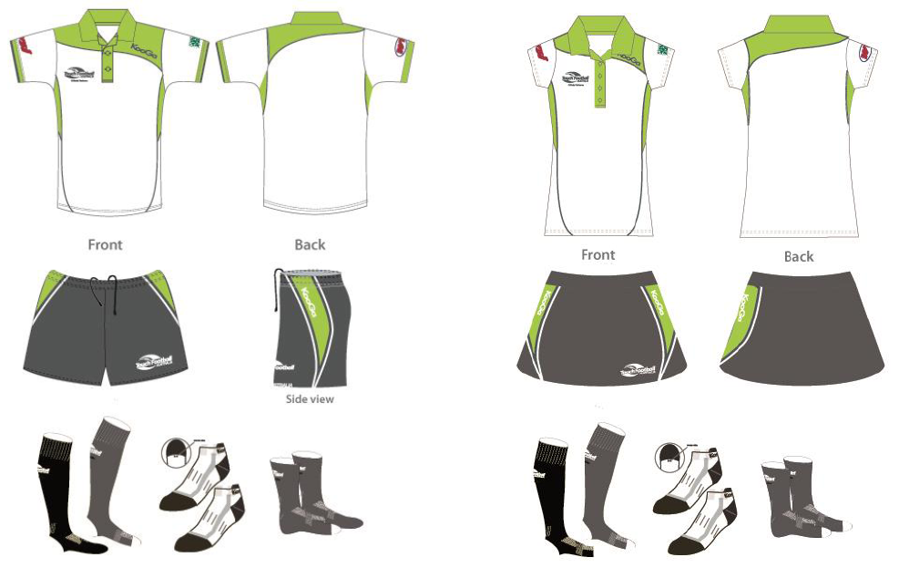
When wearing a hat during Hornets tournaments, please note that it must be a Hornets/NSWTA/TFA or generic hat.
No affiliate hats are to be worn whilst refereeing games.

REFEREES MEETING & SIGN ON
ALL REFEREES must attend the pre-tournament meeting.
This meeting will take place at 7.10am SHARP, at the fields on
Saturday 1 February 2020
It is important that all referees attend this meeting.
In addition, there will be a sign on sheet which every referee must sign on
the day of tournament to ensure all referees from clubs are in attendance.

Team Leaders Meeting
There will be a brief team leaders meeting at 7.00AM Sharp outside of the referees’ tent. Only team leaders and panel members are required at this meeting

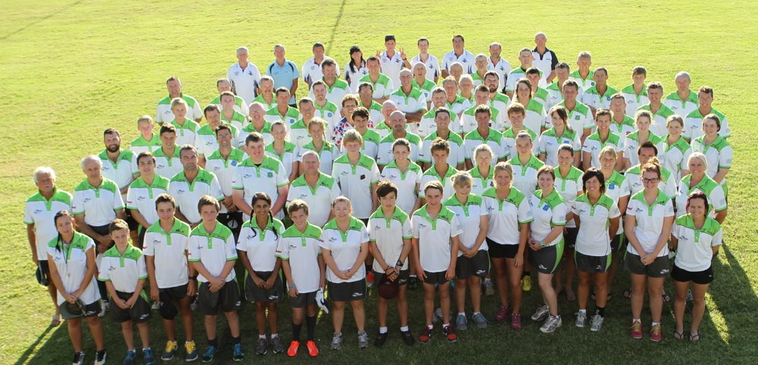

Your Tournament Coordinator
BEFORE LEAVING HOME
AND ON ARRIVAL
INFORMATION FOR FIRST TIME REFEREES AT THIS EVENT

Those of you who are refereeing at this tournament for the first time, welcome and thank you for nominating. We hope your experience at this tournament is nothing less than enjoyable and rewarding.

The golden rule is ASK another Referee if you are unsure, they are all willing to help.

Before you leave home.
- We ask that all Referees check their referee uniform. If you don’t have shorts, long socks etc. please don’t panic. Gear can be purchased through TFA. It’s a good idea to bring a fresh change of uniform for each day, though if you have a laundry facility available then you can easily get by with one set.
- A sports water bottle (or two) is essential. The Referees Tent is well catered for with fresh cold water, fruit, tea, coffee, ice and LOLLIES. Bringing your favourite sport instant drink mix e.g. Gatorade, Power aid etc. is also a good idea.
- Coins to take the toss (need more than one as they seem to disappear) and pen/pencils to mark the score card.
- A coat hanger and t-shirt so after a game you can change into a dry T-shirt and hang your referee shirt.
- A hat and sunscreen….. and lots of it. The managers have sunscreen as well on the table in the tent.
- Give your loved ones a kiss before leaving as you may well be too tired to do so when you return home.
- It is a great idea to label gear.

At the Grounds
- Find your team leaders.
- Go to the Referee table and highlight your name on the first few games sheets and then return to the table at a later time when it is quieter and highlight each game you have been allocated for the entire day.
- Make sure you are aware of your game times for the whole day and always be aware of when your next game is.
- Referees must be in the tent to collect the game card 10 minutes prior to game time.
- RETURN the score card to the referee table after the game.
- If you are free from games at any stage, or your name doesn’t appear, please see the Managers and they can add your name to the Spare Referees List on the bottom of the time sheet.
- If you get injured or are concerned with injury, discuss this with your Team Leader, or the event First Aid. It is crucial to prepare for each game as it is a long weekend.
- Check the start time for the following day before leaving each day as some days have different start times.

Referee Assessments and Coaching
- Each Referee will be coached/assessed at least once by a member of my Referee Panel.

Most of all we hope you enjoy your first venture at our Hornets event.
Things you need to know about this tournament

There is a ZERO tolerance of Abuse towards referees.
PROCEDURES
IN GAME
In relation to communication with a Referee during the game, the Coach and/or Team Captain are able to engage with the referee in a respectful and polite manner and the Referee will make every effort to provide a quick and succinct response in consideration to the flow of the game as per rule 18 player note A (note this also applies to the coach). Once the response has been given in a respectful and polite manner, regardless of whether the Coach and/or Team Captain agrees the conversation is not to extend. No other players other than the Team Captain shall engage in this protocol. IN GAME ENGAGEMENT PROTOCOL New South Wales Touch Association Game Participants Mutual Respect Policy Keeping Our State Active Page 3 If this protocol is breached on field by the Team Captain or another player, referees are instructed to undertake the following procedure to ensure an abuse and harassment free environment.
On first occurrence- a penalty 10metres forward of the mark and general warning to Team Captain.
On second occurrence- a penalty 10metres forward of the mark and the offending player given ‘forced substitution’.
On third occurrence- a penalty 10metres forward of the mark and the offending player given a ‘period of time’.
On fourth occurrence- a penalty 10metres forward of the mark and the offending player to be ‘sent off’. (see note 1) An incident report (see note 3) lodged and in this instance the offending player will receive a D2 Level 2 grading under the NSWTA Disciplinary Suspension Policy which carries a minimum 3 match suspension.
Any action by a participant that is deemed to be ‘Strong to very strong offensive, insulting or abusive words, gestures or actions, including discriminatory, racist, religious, ethnic or sexist remarks’. Is to be dealt with by the referee in the normal manner as per the rules of the game.
If this protocol is breached by the Coach, team Management, Sub box or spectator’s referees are instructed to undertake the following procedure to ensure an abuse and harassment free environment.
On first occurrence- a penalty at the prescribed mark (see note 2) and general warning to Coach and Team Captain.
On second occurrence- a penalty at the prescribed mark (see note 2) and an on field player (Captain when applicable)given ‘forced substitution’.
On third occurrence- a penalty at the prescribed mark (see note 2) and an on field player (Captain when applicable) given a ‘period of time’.
On forth occurrence- a penalty at the prescribed mark (see note 2) and the offending Coach/Team Management/Player to be ‘sent off’ (see note 4). An incident report (see note 3) lodged and in this instance the offending person will receive a D2 Level 2 grading under the NSWTA Disciplinary Suspension Policy which carries a minimum 3 match suspension.
NOTE 1 Any action by a participant that is deemed to be ‘Strong to very strong offensive, insulting or abusive words, gestures or actions, including discriminatory, racist, religious, ethnic or sexist remarks’. Is to be dealt with by the referee in the normal manner as per the rules of the game. That is the protocol may not be used in such incidents.
NOTE 2 For breaches by the Coach, Team Management, Sub box or spectator’s penalty will be awarded to the non- offending team at the point of greatest advantage from where the incident took place. e.g. Should the non-offending team be defending in their own half the mark for the penalty would be 5 meters’ infield from the offending sub box on 10 metre in the New South Wales Touch Association Game Participants Mutual Respect Policy Keeping Our State Active Page 4 oppositions half. If the non-offending team is in the attacking zone, the mark would be 10 metres forward of the current point of attack following the allowance of advantage.
NOTE 3 Lodgement of incident reports by referees or officials of abusive or harassing behaviors may lead to a suspension or sanction including but not limited to a fine or suspension to the offending party and affiliate.
NOTE 4 Any person sent off, whether it be from the field or from the sub box is to immediately retire a distance of no closer than 50metres from the team’s sub box. For games played in venues that are enclosed by a fence, then they are to retire to behind the fence line.
POST GAME
At completion of the game the Captain and the Coach are permitted to engage with the referees. This is to be done in a respectful and polite manner. They are entitled to ask in a respectful and polite manner for a clarification and the referees will in a respectful and polite manner provide a short succinct answer. The conversation should not escalate from there regardless if the Captain and or the Coach agree with the response. If the Coach wishes to further discuss with the referee/s they will be able to do so following the 30min cooling off period.

Appointments
- Appointments for all round games will be made by the Regional Director of Referees.
- NB. If for any reason you are unavailable to attend and complete your allocated appointment, please be considerate of others and give as much notice as possible. It makes life heaps easier on panel members and team leaders who need to fill vacant positions and also on your fellow referees who need support.
- Only the best performed Referees at this tournament will be awarded Final appointments, prior rating or badge level, National or otherwise, will not be a consideration.
IMPORTANT: REFEREES ARE REQUIRED FOR THE ENTIRE TOURNAMENT.

Referee Coaching and Assessments
- The Regional Referee Coaching Panel is determined to see as many referees as possible. They will provide you with immediate feedback. Make sure you fully understand what the assessor has told you so as you can employ any improvements in your following games. Make sure you are fully conversant with the contents. If you require any further assistance, please don't hesitate to seek out either myself, or the member of the Coaching Panel that completed the evaluation sheet, for a more in depth analysis of your performance.

Level 2 Upgrades
- An opportunity exists for Referees, who have attended the Level 2 Course, to be upgraded to Level 2.
- Nominations for this Level must be made through and endorsed by your Club Director of Referees. The Regional Director must have these nominations before upgrade will be made.
- Upgrades will be announced on the Sunday morning of the tournament, if possible.
- Referees Panel Members will be completing the TFA Level 2 Referees checklist for Referees nominated for upgrading. At this stage panel members will be available to discuss the contents of these sheets and provide you with direction for the future, whether or not you have been successful with an upgrade.
- To nominate for your Level 2 Upgrade, please notify the Regional Director of Referee on referees@hornetstouch.com.au

Scoreline Positioning
- Score line positioning is vital to the outcome of a game. The game is won and lost at this point, so you must be alert and focussed, whether you are the on field or the off field referee. As the on field referee you need to be aware of the set-up of play and where it’s likely to go so that you can be a player wide of the rollball and to react accordingly.

5m Reference Points (Buddy Referees)
- It’s simple.
  - The on field referee marks the 5 metre line for defenders,
  - The x2 off-field referees must be up with the defenders, approx. 1 metre in front (1mtr closer to the attackers) to ensure visual/eye contact with the on field referee. The exception being of course when they reach the 5m zone. Then the off-field referees can stay on the 5m line, however you must remember to move to better position for potential touchdowns.
- All three referee must also be mindful of the length/distance of each other’s 5mtrs, so try and stay as close to the other referees as possible. This involves adapting to the game, AND the referee buddies you are placed with.

In-Sync Refereeing (Team Work)
- “In Sync” refereeing is as the name implies. It’s about being aware of what your buddy is saying and supporting this. As an example, if you are the off field referee and you are communicating to the Link and/or winger that they are off side and you hear the on field referee call them on side, then go with that.
- The worst thing for players is that one referee is calling a player on side with the other calling off side and a touchdown is allowed to be scored.
- Team work among referees has now become the most vital part of refereeing. That said, you must prepare for this and work as a team for all of it to become successful.
- NSWTA lean more toward a team focus with their appointments, and this will certainly play a role at regional level.

Advantage
- Advantage Play and Game flow are important aspects. Understanding what the players are trying to achieve can really assist you as a referee.
- Elimination of pedantic penalties will assist with game flow and a far better outcome for everyone.

Tournament – GAME TIMES
- All games in the tournament and final series will be TWENTY FIVE (25) minutes with a turnaround of ends after each touchdown.

Back to Basics – Coaching
At this year’s tournament the regional referee coaching panel will be going back to basics with their coaching methods. As such we will be coaching intensely with the follow;

Signals
- They must be ‘Clear and Precise’. It’s amazing how many referees are getting these wrong, or they can look sloppy. Your team leader will go through with you how to do the correct signals.
- The main signals which the regional panel will be on the lookout for are;

- Start of Game,
- Play On,
- Incorrect Rollball,
- Voluntary Rollball (and knowing the difference),

- Touchdown,
- Late Pass,
- Forward Pass,
- Mexican Standoff (not moving forward),
- Not Retiring (coming back to the line),
- Rough Play,
- Backchat
- Period Of Time,
- Sent for Remainder of Game (should this be required

TEAM 1  Team Leaders:  Alec Clark  Liam Anderson  Steven Naumovski – 4 – Saturday only  Caleb Walz – 3  Bernard Law - 3  Richard Spain – 2  Ryan Kriss – 2  Ronan Hunt-Cameron – 2  William Clarke – 2  Grant Doherty - 1  Cooper Thornhill – 1  9 | TEAM 2  Team Leaders:  John Clark  Anthony Boza  Malcolm Ward – 4  Kyla Tucker – 3  Kurt Grogan - 3  Ian McMaster – 2  Jackie O’Bray -2  Sam Steedman – 2  Marisa Cole - 1  Joshua Bohan – 1  Riley Squires – 1  9 | TEAM 3  Team Leaders:  Tony Collins  Deacon Cameron  Joey Campbell – 4  Tyreece Anderson – 3  Jordan Eade – 3  Ayden Cook – 2  Drewe Gilbert – 2  Shawn Green -2  Blake Coultard - 1  Samuel Munro -1  Lucy Knight -1  9 | TEAM 4  Team Leaders:  John Frost  Dave Casson  Graham Goodwin – 4  Blake Brown – 3  Harrison Lack – 3  Nicolle Western – 2  Isabel Doherty – 2  Jamie McSpadden – 2  Aajay Watts - 1  Chris Mikulski -1  Joshua Eggins – 1  9
TEAM 5  Team Leaders:  Steve Laing  Luke Fenton  Michael Haddard – 3  Darren Balzer – 3  Geoff Pensini – 2  Mitchell Galvin – 2  Aura Atkinson - 2  Jack Munro – 1  Liam Eade -1  Ellen McLeod – 1  Mitchell Stewart – 1  9 | TEAM 6  Team Leaders:  Rob McKechnie  Jeffery Gilewski  Lachlan Rousell - 3  Tony Edmond - 3  Matthew Guy – 2  Hilary Anderson – 2  Samuel Gatt – 2  Holly Walsh – 1  Nikita Leader -1  Josh Curl - 1  Matthew Curl  9 | TEAM 7  Team Leaders:  Lachlan Bradley  Bryce Lucas  Neil Marshall – 3  Jacob Nelson – 3  Aiden Leonard – 2  Matthew Williamson – 2  David Griffiths – 2  Aaliyah Paki – 2  Brody Scott – 1  Jack Duffield -1  Jack Jones -1  9 | TEAM 8  Team Leaders:  Angela Budai  Beth Monk  Michelle Moana – 3  Vicki Wassens – 3  John Wilkins – 2  BJ Nelson – 2  Chloe Dudgeon – 2  Anthony Miles - 2  Hayden Ryan – Hill - 2  Oscar Edgerton – 1  Judd Allen – 1  9
TEAM 9  Team Leaders:  Ivan Cole  Darren Lampard  Daniel Kustec - 5  Ashley Fullick – 3  Cooper Jones – 3  Kurt Woodward - 2  Ella Carnegie - 2  Brendan Wesley – 2  Grant Kenny – 1 – Saturday only  Matthew Lackenby – 1  Jonathon Farrington -1  9 | TEAM 10  Team Leaders:  Paul George  Mason Colwell  Mick Melick – 3  Lachlan Brooks -3  Claire Spain – 2  Joanna Walsh – 2  Anthony Miles – 2  Mark Jones – 2  Kayla-Anne Hodge - 1  Felix Tebbutt – 1  Alex Stafa -1  9 | TEAM 11  Team Leaders:  Phil Balcombe  Tony Bradley  Warren Steedman - 4  Chris Nesbitt – 3  Trisha Cortaville – Smith – 3  Brad Mitchell – 2  Marnie Fullerton -2  Sophie Hinde – 2  Darren McSpadden – 2  Chris Green – 1  Jacob Cordina – 1  9 | TEAM 12  Team Leaders:  Amy Draper  Mo Moana  Phil Rainger - 5  Brock Howard – 3  Harrison Tye – 3  Bridie Melick – 2  Adam Dangel -2  India Draper – 2  Savannah Draper - 2  Oliver Schumaker – 1  Emma Brady -1  9
Team 13  Team Leaders:  Patrick Moran  Josh Fishlock  Greg Grey - 4  Ahren Scott – 3  Krystal Laughton – 3  Zana Cohen – Sunday only  Caitlin Sherry – 2  Connor Lockyer – 2  Blake Jones – 1  Brodie Pleasance – 1  Charli Balzer – 1  9 | TEAM 14  Team Leaders:  Murray Power  Marty Robertson  Paul Coggan – 3  Paula Birch – 3  Sharyn Glachan – 2  Nikyha Gentles – 2  Mia Kelsey - 2  Cain Selwood – 2  Daniel Chapman – 1  Bernard Doran -1  8 | Team 15  Team Leaders:  Nicole Dickson  Cody Reynolds  Mick Medlin – 6  Dean Hagley – 3  Josh Armstrong – 3  Robert Baker - 2  David Aoake -2  Matthew Norris – 2  Andrew Grimley -1  Connor Green -1  9 | Team 16  Team Leaders:  Craig South  Damon Cupitt  Victor Naumovski – 6 Saturday only  Lachlan Lucas – 3  Neil Webster – 3  Brett Murrell – 2  Mia Mikulski - 2  Matthew Roberts – 2  Liam Galvin – 1  Harrison Francis – 1  8

